**Institute of Engineering & Management**

**Department of Computer Science & Engineering**

**Computer Architecture Laboratory for 2nd year 4th semester 2018**

**Code: CS 493**

**Date:** 24/02/2018

**WEEK-4**

**Assignment-1:** Conversion from Binary to Grey number & Grey to Binary using Xilinx ISE.

**Objective:** Convert 4bit binary to grey

|  |  |
| --- | --- |
| **Property Name** | **Value** |
| Device family | Spartan 3 |
| Device | XC3S50 |
| Package | PQ208 |
| Speed | -5 |
| Top-level source type | HDL |
| Synthesis Tool | XST(VHDL/Verilog) |
| Simulator | ISE Simulator |
| Preferred Language | VHDL |

**Software used:**

**Theory:**

1. Make VHDL with required port specification.
2. Calculate the value c for both data flow and behavioural model using if and else statement with required condition.
3. Make test bench waveform and check for the given inputs.

**Truth Table:**

|  |  |  |  |  |
| --- | --- | --- | --- | --- |
| **BINARY** | **GREY** |  | **BINARY** | **GREY** |
| 0000 | 0000 |  | 0010 | 0011 |
| 0001 | 0001 |  | 1010 | 1111 |
| 1111 | 1000 |  | 0111 | 0100 |
| 1011 | 1110 |  | 0100 | 0110 |

**Behavioural Model:**

**Data flow Model:**

**Code:   
Behavioural Model Code:**entity abcd is  
 Port ( b : in STD_LOGIC_VECTOR (3 downto 0);  
 g : out STD_LOGIC_VECTOR (3 downto 0));  
end abcd;  
architecture Behavioral of abcd is  
  
begin process(b)  
Begin  
g(3)<=b(3);  
for i in 2 downto 0 loop  
if b(i)=b(i+1) then  
g(i)<='0';  
else  
g(i)<='1';  
end if;  
end loop;   
end process;  
end Behavioral;  
 **Data Flow Model Code:**entity abcd is  
 Port ( g : in STD_LOGIC_VECTOR (3 downto 0);  
 b : out STD_LOGIC_VECTOR (3 downto 0));  
end abcd;  
architecture Behavioral of abcd is  
  
begin process(b)  
begin  
g(3)<=b(3);  
g(2)<=b(3) xor b(2);  
g(1)<=b(2) xor b(1);  
g(0)<=b(1) xor b(0);  
end process;  
end Behavioral;

**Output:**

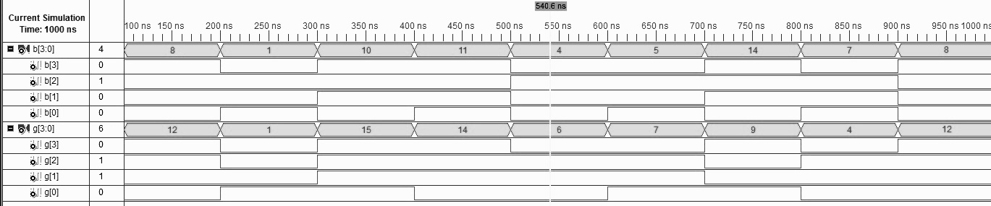

**Objective:**  Convert 4 - bit grey to binary

|  |  |
| --- | --- |
| **Property Name** | **Value** |
| Device family | Spartan 3 |
| Device | XC3S50 |
| Package | PQ208 |
| Speed | -5 |
| Top-level source type | HDL |
| Synthesis Tool | XST(VHDL/Verilog) |
| Simulator | ISE Simulator |
| Preferred Language | VHDL |

**Software used:**

**Theory:**

1. Make VHDL with required port specification.
2. Calculate the value c for both data flow and behavioral model using if and else statement with required condition.
3. Make test bench waveform and check for the given inputs.

**Truth Table:**

|  |  |  |  |  |
| --- | --- | --- | --- | --- |
| **GREY** | **BINARY** |  | **GREY** | **BINARY** |
| 0000 | 0000 |  | 0011 | 0010 |
| 0001 | 0001 |  | 1111 | 1010 |
| 1000 | 1111 |  | 0100 | 0111 |
| 1110 | 1011 |  | 0110 | 0100 |

**Data Flow Model:**

**Behavioural Model:**

**Code:   
Behavioural Model Code:**entity abcd is  
 Port ( g : in STD_LOGIC_VECTOR (3 downto 0);  
 b : inout STD_LOGIC_VECTOR (3 downto 0));  
end abcd;  
architecture Behavioral of abcd is  
begin process(g,b)  
begin  
b(3)<=g(3);  
for i in 2 downto 0 loop  
if g(i)=b(i+1) then  
b(i)<='0';  
else  
b(i)<='1';  
end if;  
end loop;   
end process;  
end Behavioral;  
  
  
**Data Flow Model Code:**  
entity abcd is  
 Port ( g : in STD_LOGIC_VECTOR (3 downto 0);  
 b : out STD_LOGIC_VECTOR (3 downto 0));  
end abcd;  
architecture Behavioral of abcd is  
begin process(g)  
begin  
b(3)<=g(3);  
b(2)<=g(3) xor g(2);  
b(1)<=g(3) xor g(2) xor g(1);  
b(0)<=g(3) xor g(2) xor g(1) xor g(0);  
end process;  
end Behavioral;

**Output:**

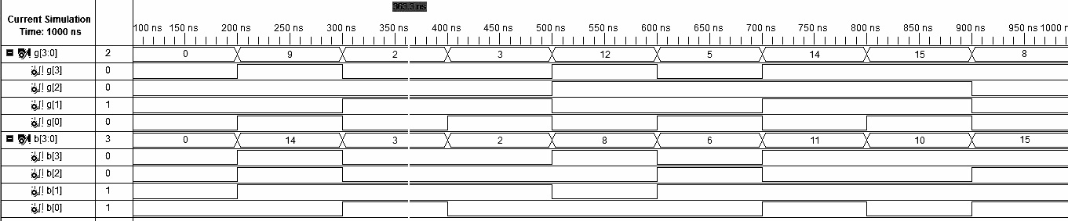

**Assignment-2:** Implementation of 4:2 encoder using Xilinx ISE.

**Objective:**  Implement a 4:2 encoder with behavioural code.

|  |  |
| --- | --- |
| **Property Name** | **Value** |
| Device family | Spartan 3 |
| Device | XC3S50 |
| Package | PQ208 |
| Speed | -5 |
| Top-level source type | HDL |
| Synthesis Tool | XST(VHDL/Verilog) |
| Simulator | ISE Simulator |
| Preferred Language | VHDL |

**Software used:**

**Theory:**

1. Make VHDL with required port specification.
2. Calculate the value c for both data flow and behavioral model using if and else statement with required condition.
3. Make test bench waveform and check for the given inputs.

**Truth Table:**

|  |  |
| --- | --- |
| **Input** | **Output** |
| 0001 | 00 |
| 0010 | 01 |
| 0100 | 10 |
| 1000 | 11 |

**Behavioural Model:**

**Behavioural Model Code:**

entity a1 is  
 Port ( a : in STD_LOGIC_VECTOR (3 downto 0);  
 b : out STD_LOGIC_VECTOR(1 downto 0));  
end a1;  
architecture Behavioral of a1 is  
  
begin  
process(a)  
begin  
if a(3)='1' then  
b<="11";  
elsif a(2)='1' then  
b<="10";  
elsif a(1)='1' then  
b<="01";  
elsif a(0)='1' then  
b<="00";  
end if;  
end process;  
end Behavioral;

**Output:**

